BANK LOAN REPORT| SUMMARY
TOTAL LAON APPLICATIONS
SELECT COUNT(ID)AS Total_loan_application FROM[dbo].[bankloandata]
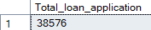
MTD LOAN APPLICATIONS
SELECT COUNT(ID)AS MTD_Total_loan_application FROM[dbo].[bankloandata]
WHERE MONTH(issue_date) =12 AND YEAR(issue_date)=2021
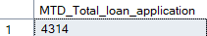

PMTD LOAN APPLICATIONS

SELECT COUNT(ID)AS PMTD_Total_loan_application FROM[dbo].[bankloandata]
WHERE MONTH(issue_date) =11 AND YEAR(issue_date)=2021
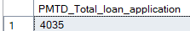
TOTAL LOAN AMOUNT
SELECT SUM(loan_amount)AS Total_loan_amount FROM[dbo].[bankloandata]

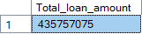
MTD TOTAL LOAN AMOUNT
SELECT SUM(loan_amount)AS MTD_Total_loan_amount FROM[dbo].[bankloandata]
WHERE MONTH(issue_date) =12 AND YEAR(issue_date)=2021

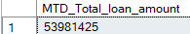

PMTD TOTAL LOAN AMOUNT
SELECT SUM(loan_amount)AS PMTD_Total_loan_amount FROM[dbo].[bankloandata]
WHERE MONTH(issue_date) =11 AND YEAR(issue_date)=2021

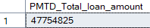
TOTAL AMOUNT RECEIVED
SELECT SUM(total_payment) AS TOTAL_AMOUNT_RECEIVED FROM[dbo].[bankloandata]
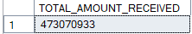
MTD TOTAL AMOUNT RECEIVED
SELECT SUM(total_payment) AS MTD_TOTAL_AMOUNT_RECEIVED FROM[dbo].[bankloandata]
WHERE MONTH(issue_date) =12 AND YEAR(issue_date)=2021

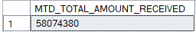
PMTD TOTAL AMOUNT RECEIVED
SELECT SUM(total_payment) AS PMTD_TOTAL_AMOUNT_RECEIVED FROM[dbo].[bankloandata]
WHERE MONTH(issue_date) =11 AND YEAR(issue_date)=2021

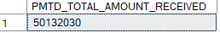
AVERAGE INTEREST RATE
SELECT ROUND(AVG(int_rate),4)*100 AS AVERAGE_INTEREST_RATE FROM [dbo].[bankloandata]
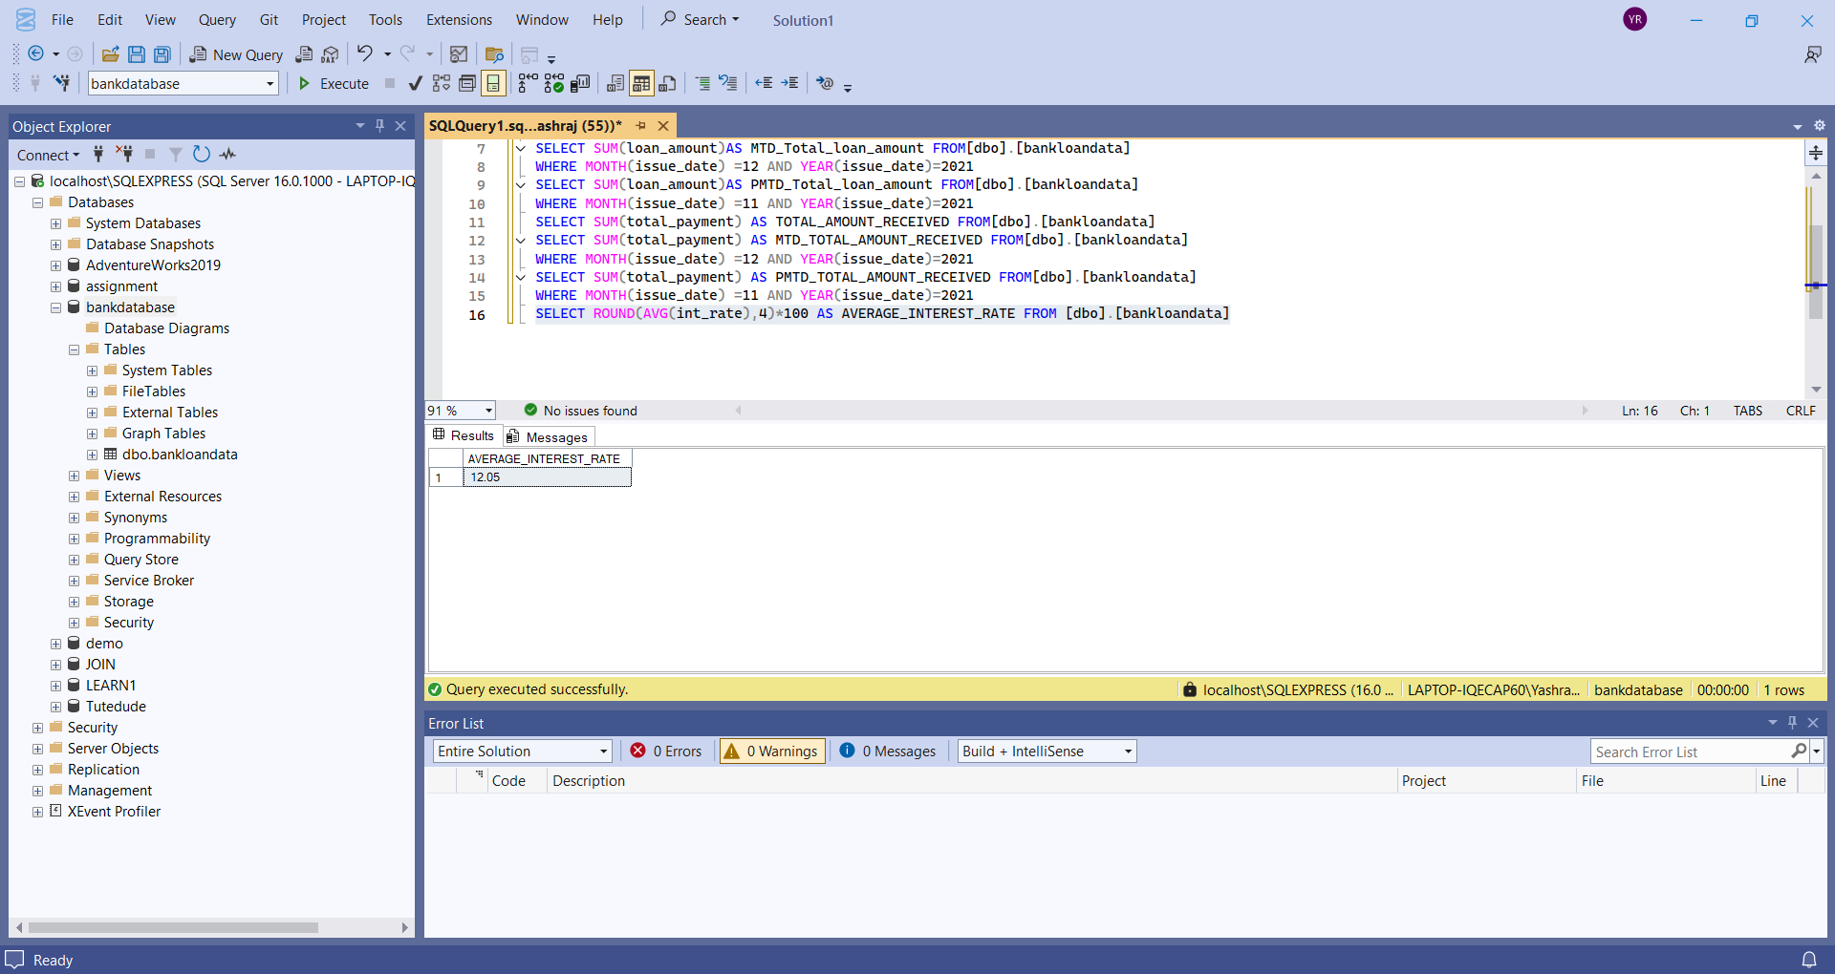
PMTD AVERAGE INTEREST RATE
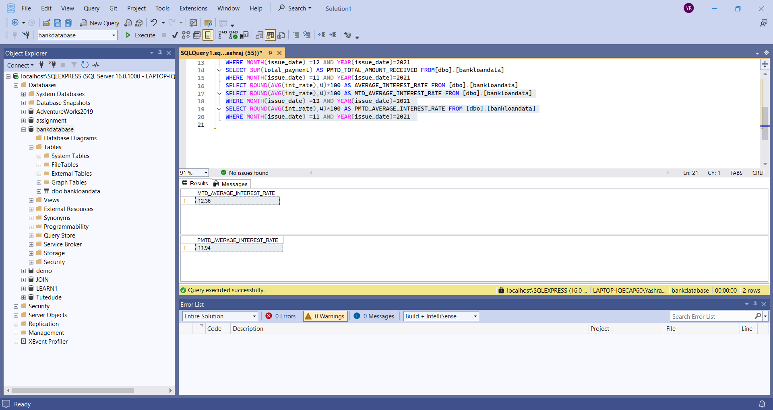
SELECT ROUND(AVG(int_rate),4)*100 AS PMTD_AVERAGE_INTEREST_RATE FROM [dbo].[bankloandata]
WHERE MONTH(issue_date) =11 AND YEAR(issue_date)=2021

MTD AVERAGE INTEREST RATE


SELECT ROUND(AVG(int_rate),4)*100 AS MTD_AVERAGE_INTEREST_RATE FROM [dbo].[bankloandata]
WHERE MONTH(issue_date) =12 AND YEAR(issue_date)=2021

AVERAGE DTI
SELECT ROUND(AVG(dti),4)*100 AS AVERAGE_DTI FROM[dbo].[bankloandata]

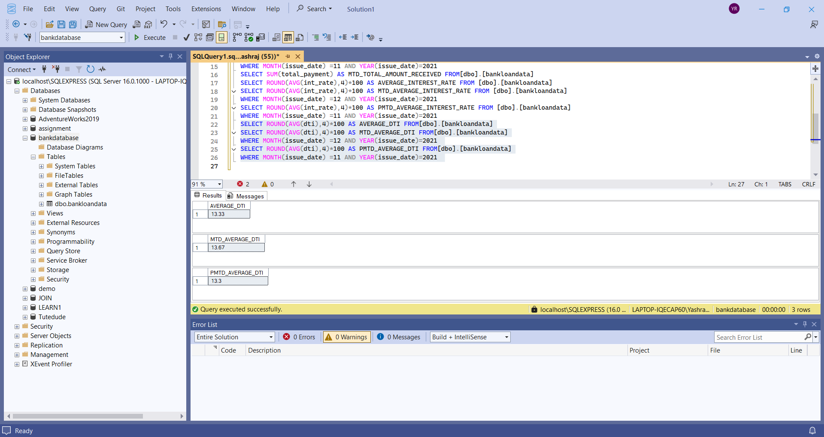

MTD AVERAGE DTI
SELECT ROUND(AVG(dti),4)*100 AS MTD_AVERAGE_DTI FROM[dbo].[bankloandata]
WHERE MONTH(issue_date) =12 AND YEAR(issue_date)=2021

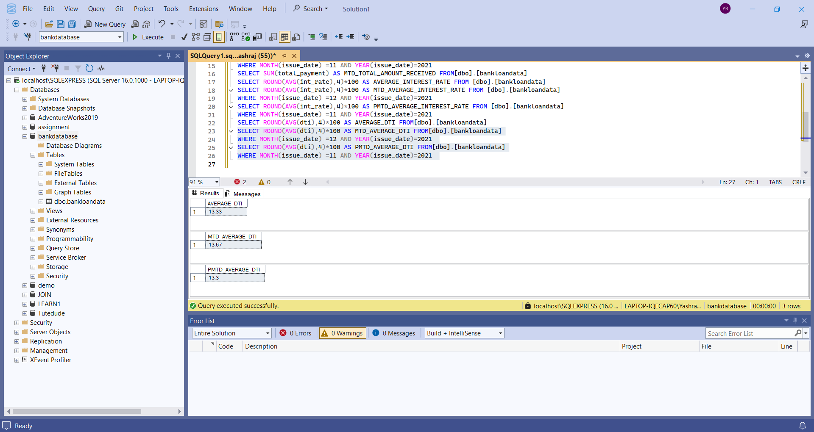

PMTD AVERAGE DTI
SELECT ROUND(AVG(dti),4)*100 AS PMTD_AVERAGE_DTI FROM[dbo].[bankloandata]
WHERE MONTH(issue_date) =11 AND YEAR(issue_date)=2021


GOOD LOANS

TOTAL GOOD LOANS
SELECT
COUNT(CASE WHEN loan_status = 'Fully paid' OR loan_status = 'Current'THEN id END)
AS TOTAL_GOOD_LOANS
FROM [dbo].[bankloandata]

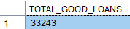

TOTAL GOOD LOAN FUND AMOUNT
SELECT
SUM (loan_amount) AS TOTAL_GOOD_LOANS_AMT
FROM [dbo].[bankloandata]WHERE ( loan_status = 'Fully paid' OR loan_status = 'Current')

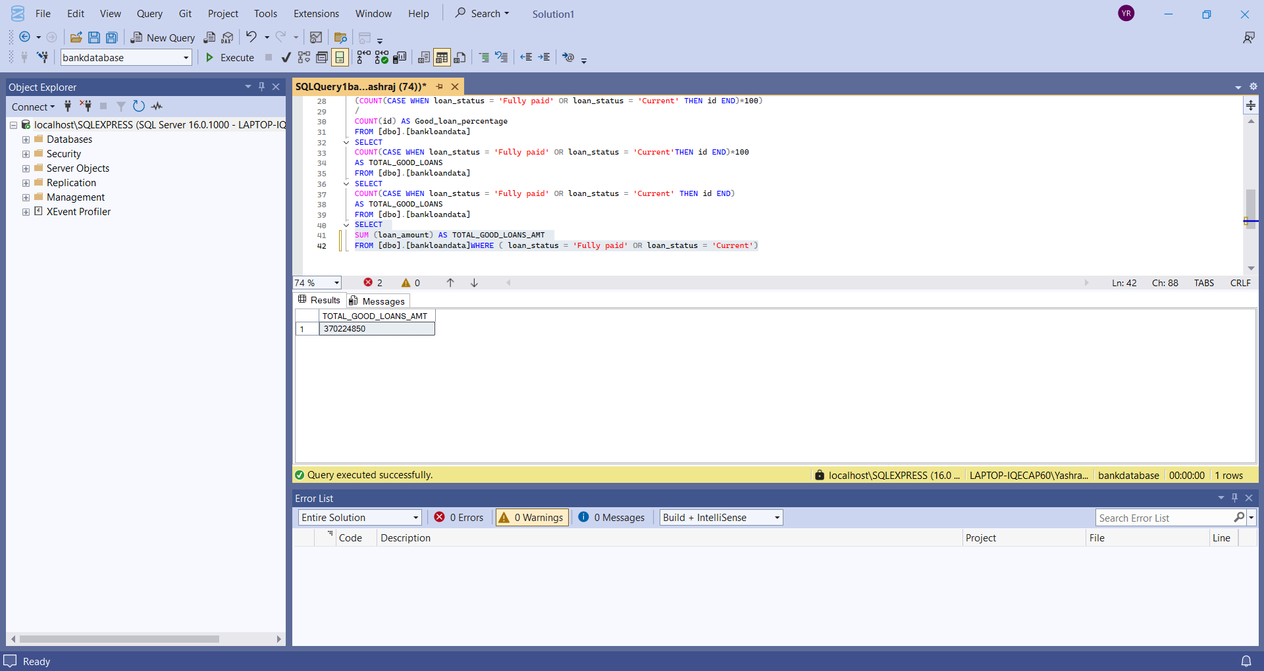

TOTAL GOOD LOAN PAYMENT
SELECT SUM(total_payment) AS GOOD_LOAN_TOTAL_PAYMENT FROM[dbo].[bankloandata]
WHERE ( loan_status = 'Fully paid' OR loan_status = 'Current')

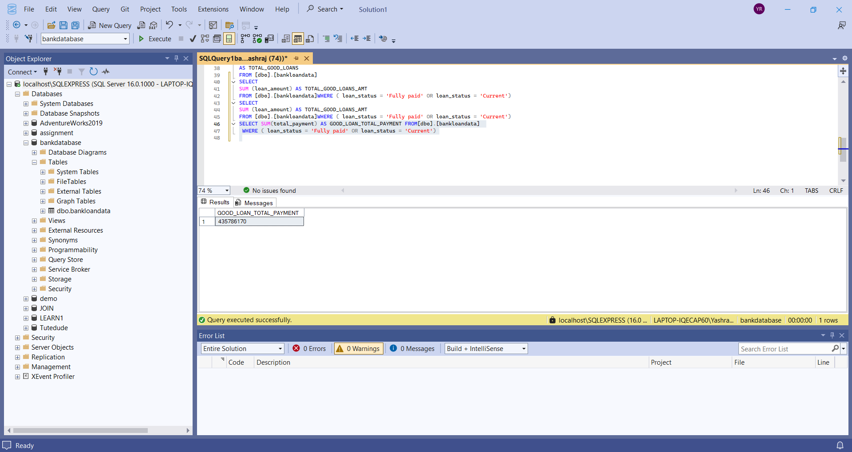

BAD LOANS

TOTAL BAD LOAN PERCENTAGE
SELECT
(COUNT(CASE WHEN loan_status = 'charged off'THEN id END)*100.0
/
COUNT(id))
AS BAD_LOAN_PERCENTAGE FROM [dbo].[bankloandata]
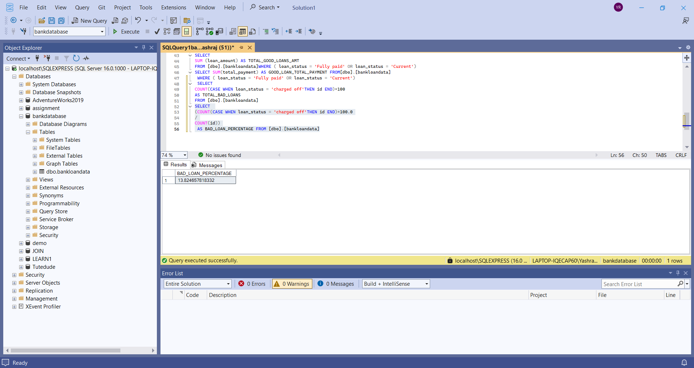

TOTAL BAD LOANS
SELECT
COUNT (id) AS TOTAL_BAD_LOANS_APPLICATIONS FROM[dbo].[bankloandata]
WHERE loan_status = 'charged off'
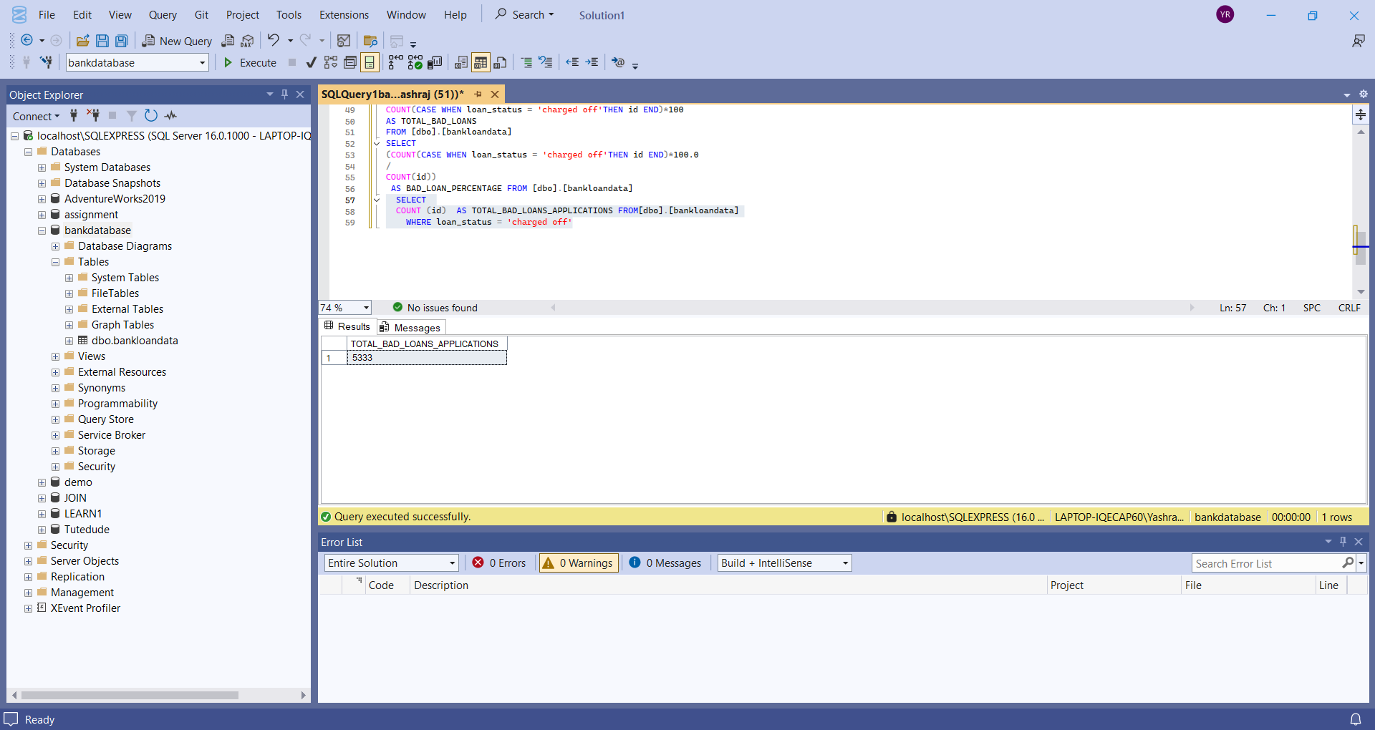
BAD LOAN FUNDED AMOUNT
SELECT SUM (loan_amount) AS BAD_LOAN_FUNDED FROM [dbo].[bankloandata] WHERE loan_status='CHARGED OFF'

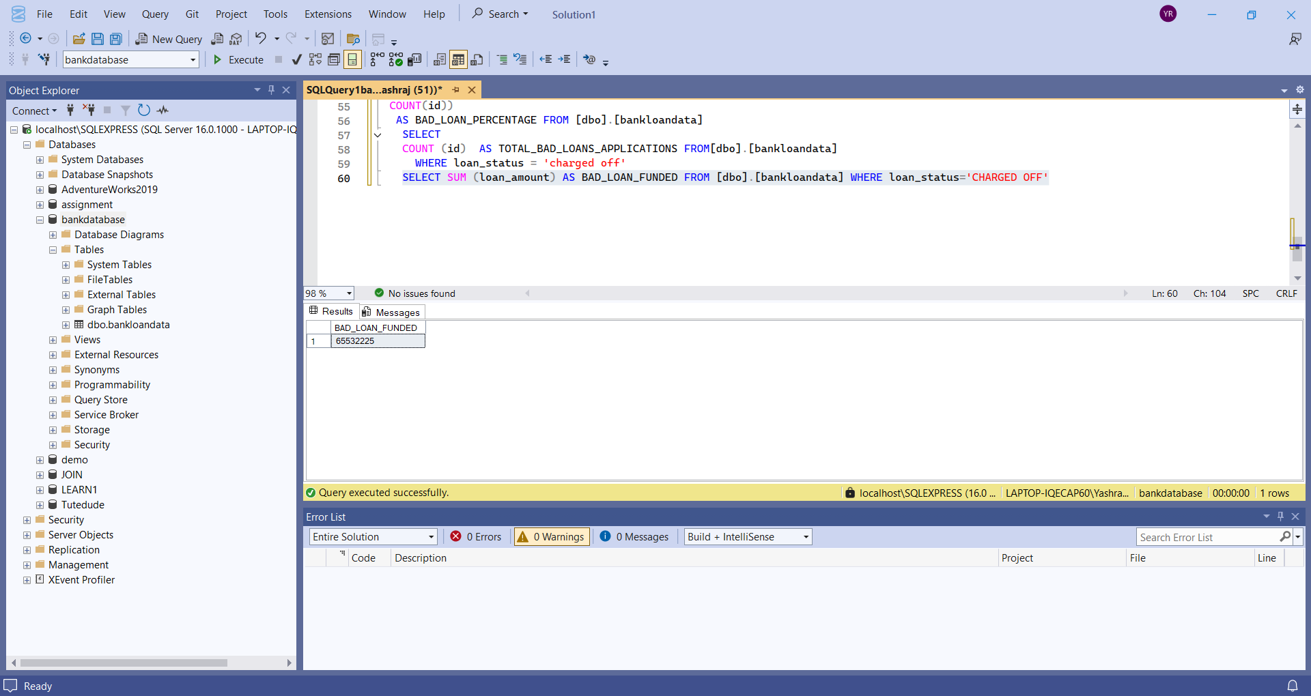

BAD LOAN PAYMENT RECEIVED
SELECT SUM (total_payment) AS BAD_LOAN_PAYMENT_RECEIVED FROM [dbo].[bankloandata] WHERE loan_status='CHARGED OFF'

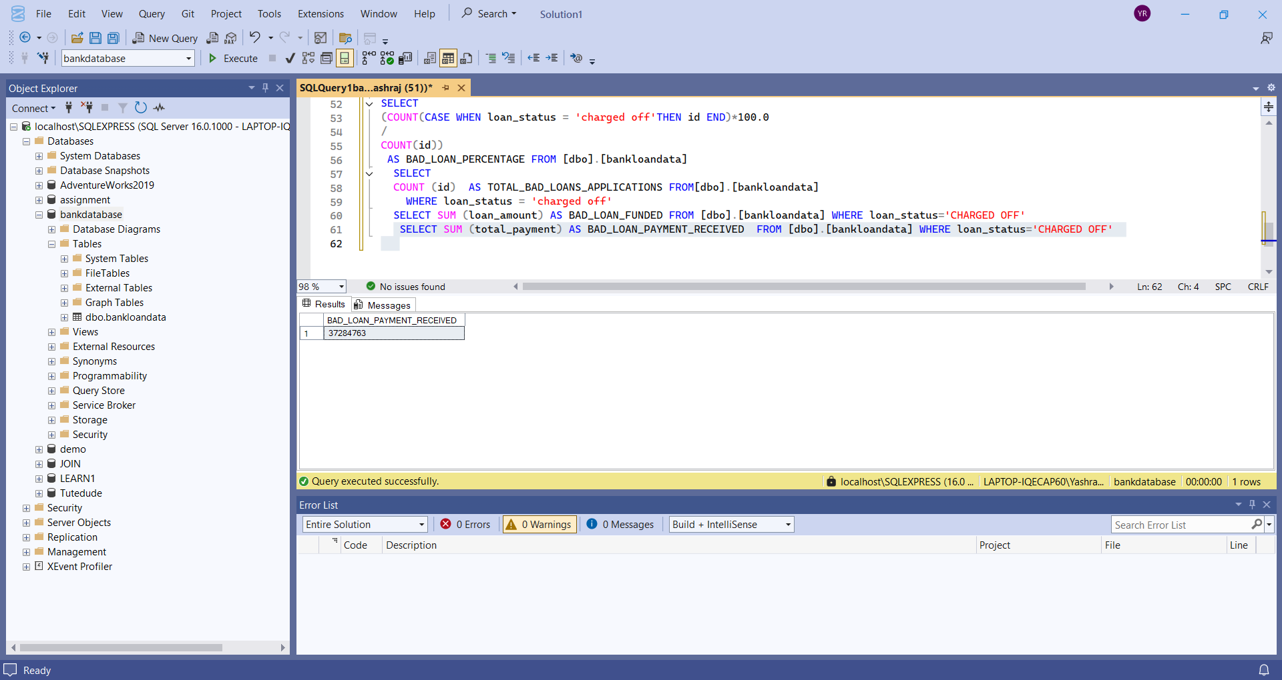
LOAN STATUS GRID
SELECT loan_status,
COUNT (id) AS TOTAL_LOAN_APPLICATIONS,
SUM(loan_amount) as TOTAL_AMOUNT_FUNDED ,
SUM(total_payment) as TOTAL_AMOUNT_RECEIVED,
AVG(int_rate*100) as AVERAGE_INTEREST_RATE ,
AVG(dti*100) as AVERAGE_DTI
from [dbo].[bankloandata]
group by loan_status

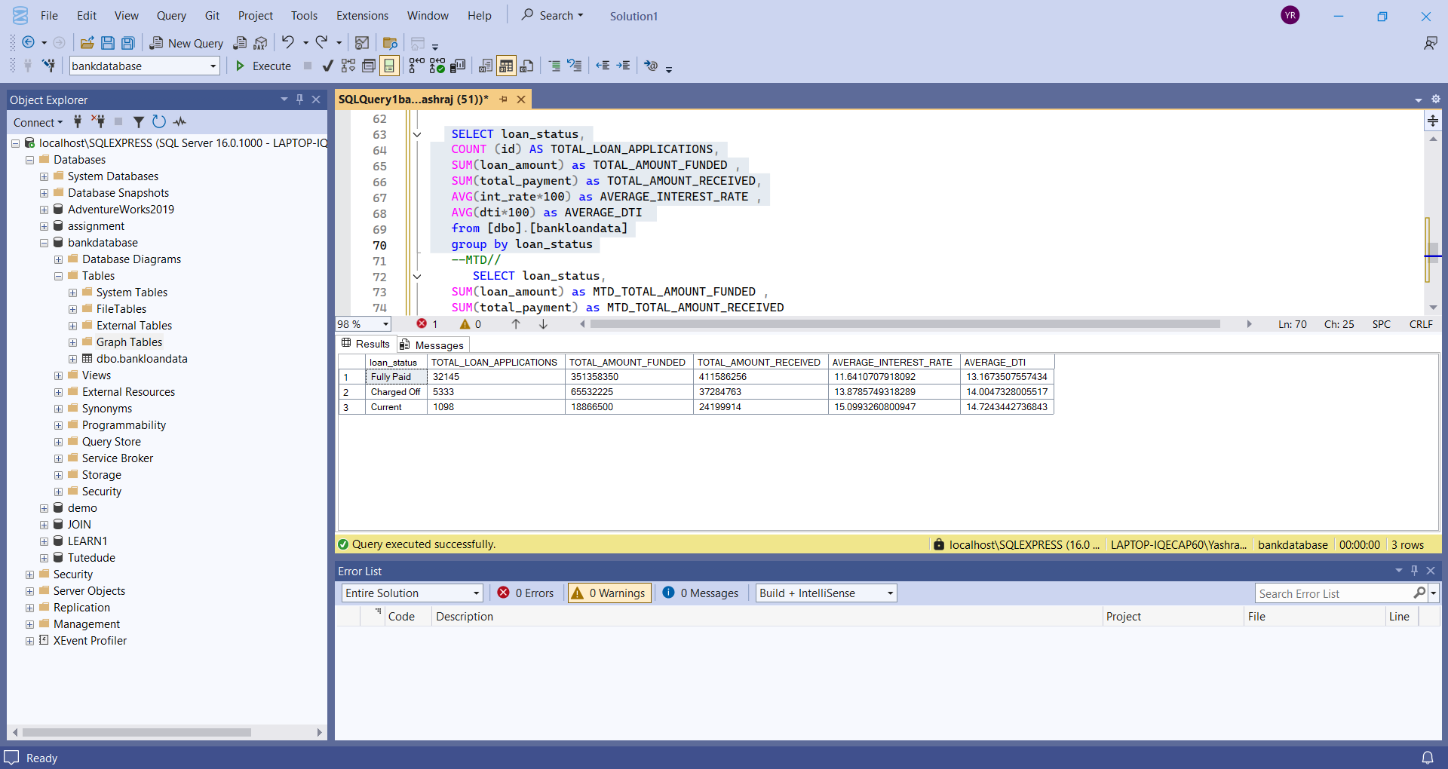

MTD GRID AND PMTD GRID
--MTD//
SELECT loan_status,
SUM(loan_amount) as MTD_TOTAL_AMOUNT_FUNDED ,
SUM(total_payment) as MTD_TOTAL_AMOUNT_RECEIVED
from [dbo].[bankloandata]
WHERE MONTH (issue_date)=12 and YEAR(issue_date)=2021
group by loan_status
--PMTD
SELECT loan_status,
SUM(loan_amount) as PMTD_TOTAL_AMOUNT_FUNDED ,
SUM(total_payment) as PMTD_TOTAL_AMOUNT_RECEIVED
from [dbo].[bankloandata]
WHERE MONTH (issue_date)=11 and YEAR(issue_date)=2021
group by loan_status

